Math 10

Lesson 6–7 Solving Problems Involving Objects

# Lesson Objectives:

1. Solve problems involving the surface area and volume of composite objects.

# Volumes and surface areas of composite objects

A *composite object* comprises two or more distinct objects. To determine the volume of a composite object, identify the distinct objects, calculate the volume of each object, then add the volumes. To calculate the surface area of a composite object, the first step is to determine the faces that comprise the surface area. Then calculate the sum of the areas of these faces.

**Example 1** The old grain bin problem



A farmer is constructing a new grain bin. The bin she would like to build has a cylindrical body and a cone-shaped roof.

a) Including the floor, what is the surface area of the grain bin?

b) The farmer’s grain truck can hold 550 cubic feet of barley. How many truckloads are required to fill the bin?

**Solution**

a) Surface area

The shape consists of a circular base, conical top and the sides of a cylinder.





5

10

*s*

b) Volume

The volume consists of a cone and a cylinder.



The grain bin can hold 11.8 truckloads of barley.



**Question 1**

Determine the volume of this composite object to the nearest tenth of a cubic centimetre.

**Question 2**

Determine the surface area of this composite object.

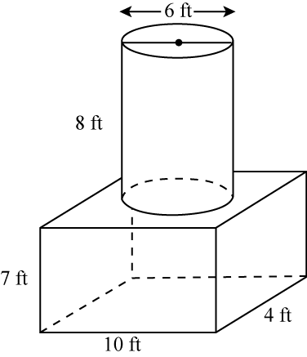**Question 3**

Calculate the surface area and volume of the following shape to the nearest tenth.

# Assignment

1. Determine the surface area and volume of each composite object to the nearest unit.

a) right cylinder and right cone b) right square prism and right square pyramid

 

c) right square prism and right cylinder d) right cone and hemisphere

 

2. a) For which composite objects in question 1 could you calculate the volumes without determining any further dimensions?

b) Determine the volume of each composite object you identified in part a.

3. Determine the surface area and volume of the object composed of a right cylinder and two hemispheres. Write the answers to the nearest tenth of a unit.



4. For each object, its surface area, *SA*, and some dimensions are given. Calculate the dimension indicated by the variable. Write each answer to the nearest tenth of a unit.

a) right cylinder b) right cylinder



5. A rocket has a cylindrical body and a cone-shaped nose. The cylinder is 55 cm long with a radius of 6 cm. The cone has a slant height of 12 cm and has the same radius as the cylinder.

a) Sketch and label a diagram of the rocket.

b) Determine the surface area of the rocket to the nearest square centimetre.

c) Determine the volume of the rocket to the nearest cubic centimetre.

d) One-third of the interior space of the rocket is used for fuel storage. How much fuel can the rocket hold?

6. Here are two different grain storage bins.

 

a) Which storage bin holds more grain?

b) Each storage bin has a cement base. The materials for the walls and roof of the square-based bin cost $10.49 per square foot. The materials for the walls and roof of the circular-based bin cost $9.25 per square foot. Which bin is cheaper to build? Justify your answer.

7. Determine the volume and surface area of each object to the nearest tenth of a unit.

a) a right square prism with a right square pyramid removed



b) a right cylinder with a hemisphere removed



8. An ice sculpture can be made by pouring water into a mould or by carving blocks of ice.

a) One mould forms a sculpture that is a composite object comprising a right cylinder with base diameter 15 in. and height 3 in., and a right cone with the same base diameter as the base of the cylinder and a height of 9 in. Determine the volume of the sculpture to the nearest cubic inch.

b) The sculpture in part a is carved out of a block of ice with the shape of a right square prism. What are the least possible dimensions for the prism to the nearest inch?

c) The sculpture in part a is carved from a block of ice with the shape of a right rectangular prism with dimensions 16 in. by 15 in. by 12 in. What volume of ice, in cubic inches, remains?